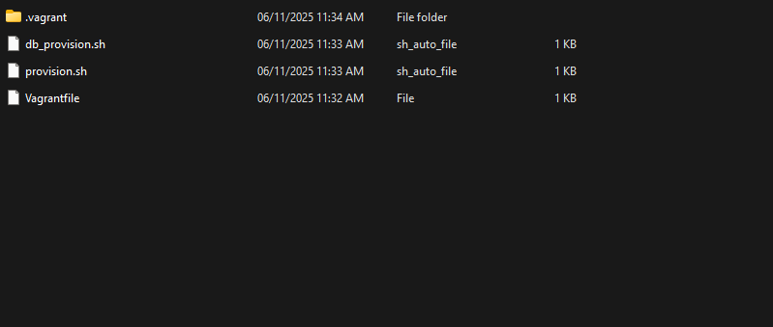

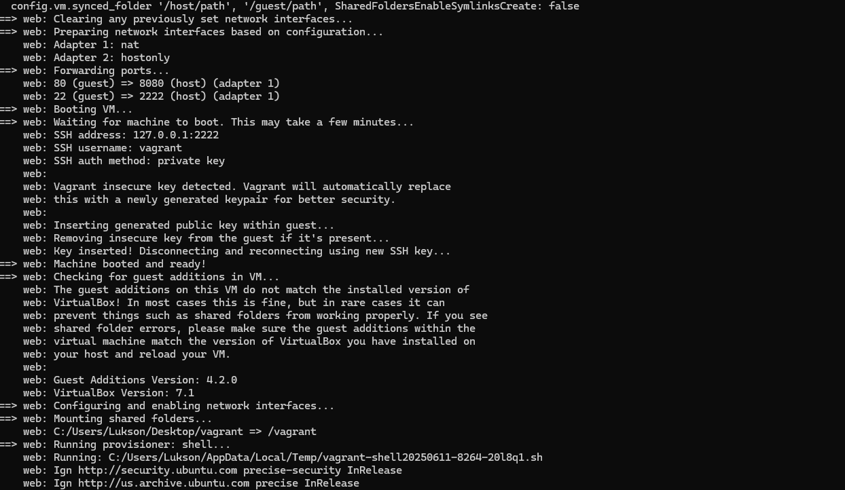

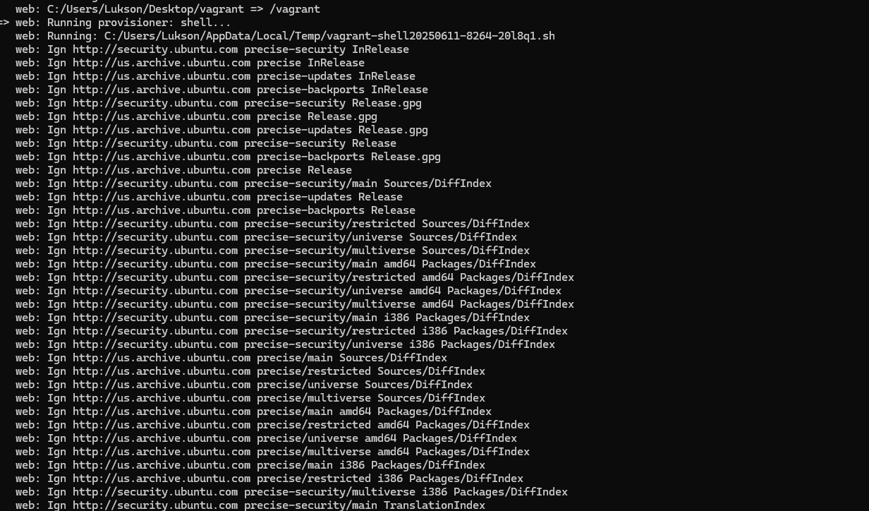

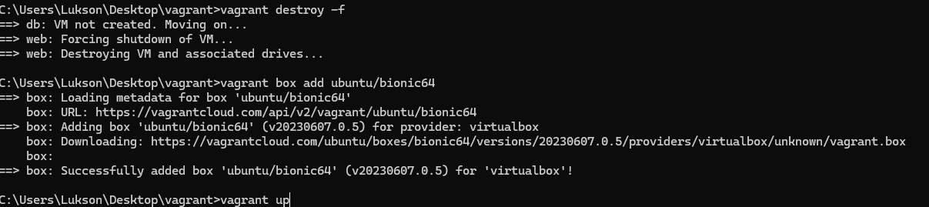

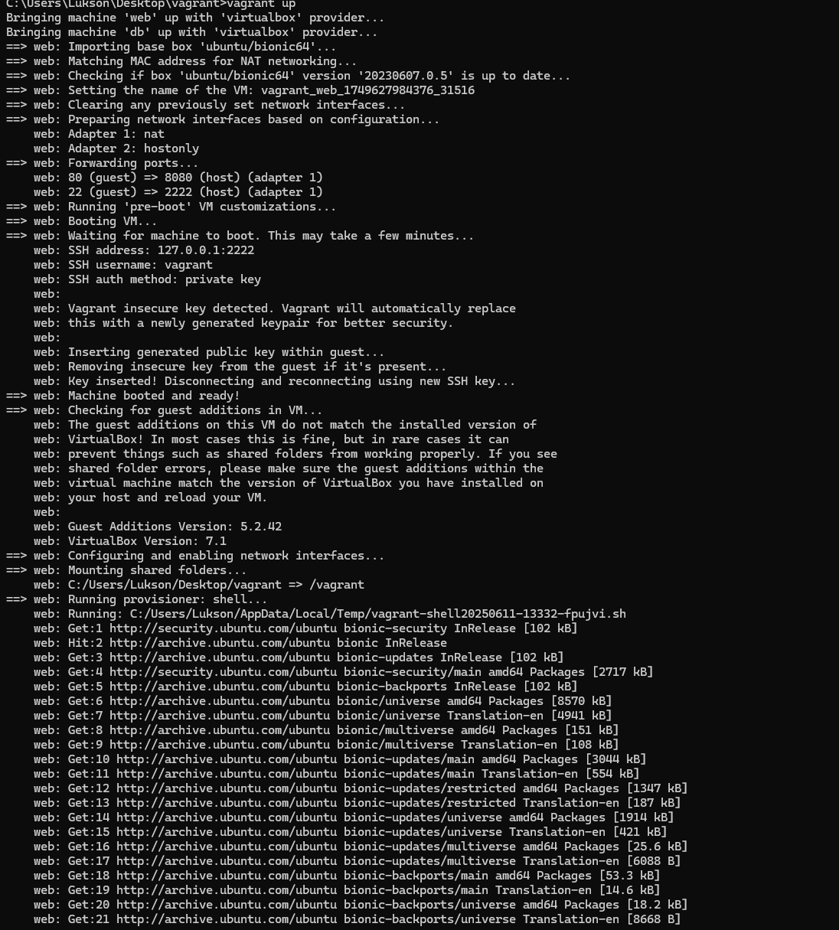

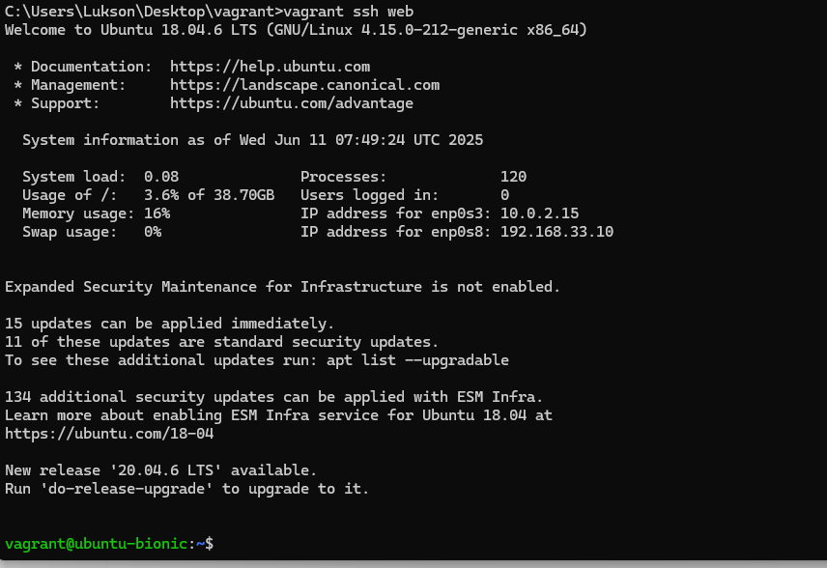

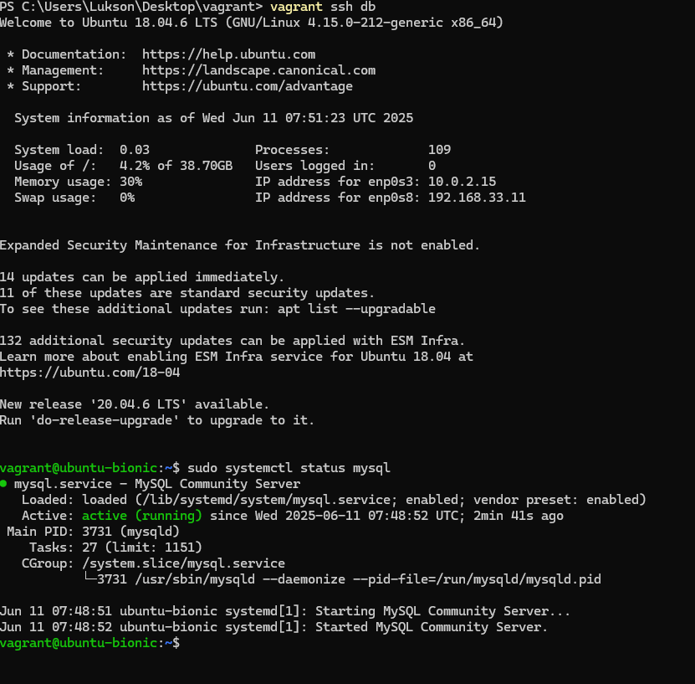

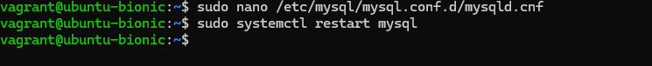

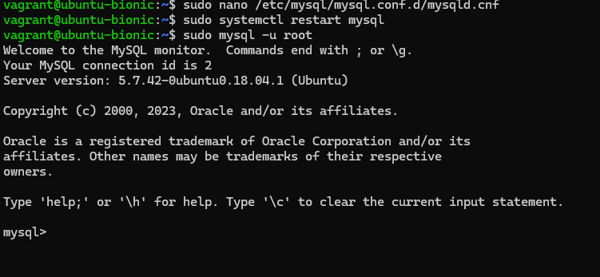

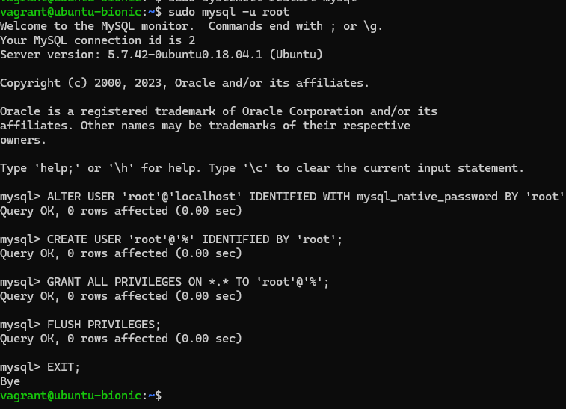

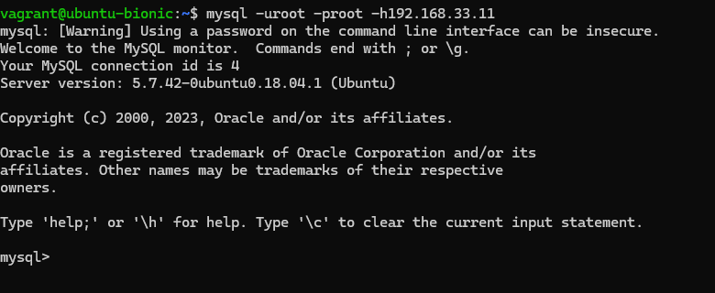

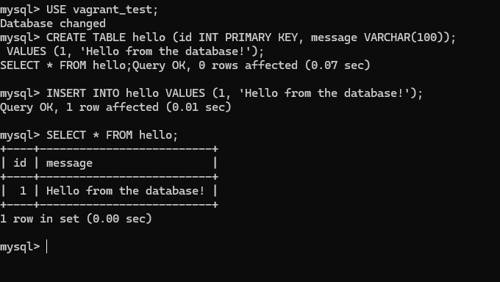

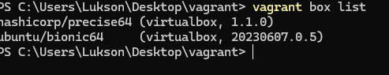

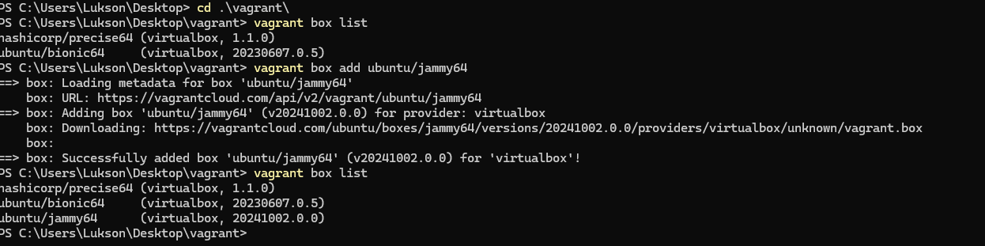

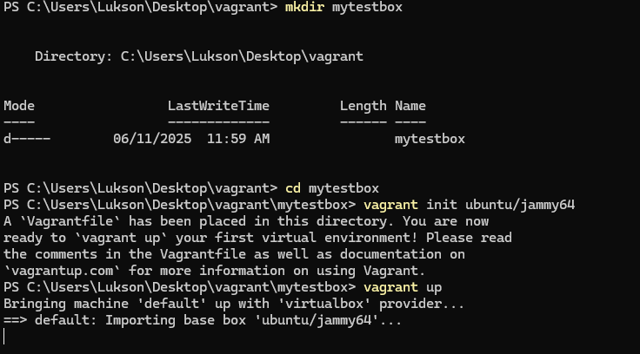

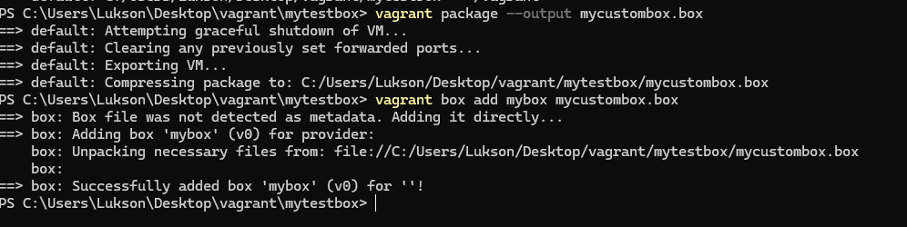

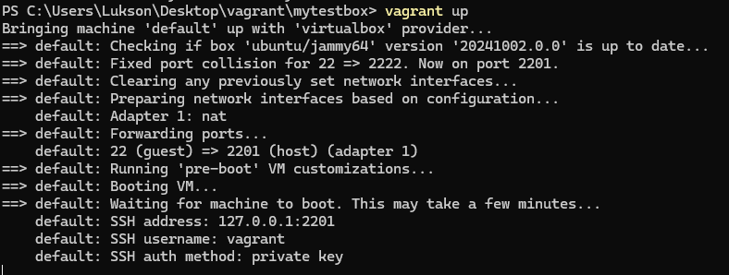

\

C:\Users\Lukson\Desktop\vagrant>vagrant up

Bringing machine 'web' up with 'virtualbox' provider...

Bringing machine 'db' up with 'virtualbox' provider...

==> web: Box 'hashicorp/precise64' could not be found. Attempting to find and install...

web: Box Provider: virtualbox

web: Box Version: >= 0

==> web: Loading metadata for box 'hashicorp/precise64'

web: URL: https://vagrantcloud.com/api/v2/vagrant/hashicorp/precise64

==> web: Adding box 'hashicorp/precise64' (v1.1.8) for provider: virtualbox

web: web:

Downloading: https://vagrantcloud.com/hashicorp/boxes/precise64/versions/1.1.0/providers/virtualbox/unknown/vagrant.box

==> web: Successfully added box 'hashicorp/precise64' (v1.1.0) for 'virtualbox'!

==> web: Importing base box 'hashicorp/precise64'...

==> web: Matching MAC address for NAT networking.

==> web: Checking if box 'hashicorp/precise64' version 1.1.0' is up to date... ==> web: Setting the name of the VM: vagrant_web_1749627709021_46797 Vagrant is currently configured to create VirtualBox synced folders with the 'Shared FoldersEnableSymlinksCreate' option enabled. If the Vagrant guest is not trusted, you may want to disable this option. For more information on this option, please refer to the VirtualBox manual:

https://www.virtualbox.org/manual/ch04.html#sharedfolders

This option can be disabled globally with an environment variable: VAGRANT_DISABLE_VBOXSYMLINKCREATE=1

or on a per folder basis within the Vagrantfile:

config.vm.synced_folder '/host/path', '/guest/path', Shared FoldersEnableSymlinksCreate: false

==> web: Clearing any previously set network interfaces...

==> web: Preparing network interfaces based on configuration...

web: Adapter 1: nat

web: Adapter 2: hostonly

==> web: Forwarding ports...

web: 80 (guest) => 8080 (host) (adapter 1)

web: 22 (guest) => 2222 (host) (adapter 1)

config.vm.synced_folder '/host/path', '/guest/path', Shared FoldersEnableSymlinksCreate: false ==> web: Clearing any previously set network interfaces...

==> web: Preparing network interfaces based on configuration...

web: Adapter 1: nat

web: Adapter 2: hostonly

==> web: Forwarding ports....

web: 88 (guest) => 8888 (host) (adapter 1)

web: 22 (guest) => 2222 (host) (adapter 1)

==> web: Booting VM...

==> web: Waiting for machine to boot. This may take a few minutes...

web: SSH address: 127.0.0.1:2222

web: SSH username: vagrant

web: SSH auth method: private key

web:

web: Vagrant insecure key detected. Vagrant will automatically replace web: this with a newly generated keypair for better security.

web:

web: Inserting generated public key within guest...

web: Removing insecure key from the guest if it's present...

web: Key inserted! Disconnecting and reconnecting using new SSH key...

==> web: Machine booted and ready!

==> web: Checking for guest additions in VM...

web: The guest additions on this VM do not match the installed version of web: VirtualBox! In most cases this is fine, but in rare cases it can

web: prevent things such as shared folders from working properly. If you see web: shared folder errors, please make sure the guest additions within the web: virtual machine match the version of VirtualBox you have installed on web: your host and reload your VM.

web:

web: Guest Additions Version: 4.2.0

web: VirtualBox Version: 7.1

==> web: Configuring and enabling network interfaces...

==> web: Mounting shared folders...

web: C:/Users/Lukson/Desktop/vagrant => /vagrant

==> web: Running provisioner: shell...

web: Running: C:/Users/Lukson/AppData/Local/Temp/vagrant-shell28258611-8264-2018q1.sh web: Ign http://security.ubuntu.com precise-security InRelease

web: Ign http://us.archive.ubuntu.com precise InRelease

web: C:/Users/Lukson/Desktop/vagrant => /vagrant

>web: Running provisioner: shell...

web: Running: C:/Users/Lukson/AppData/Local/Temp/vagrant-shell20250611-8264-2018q1.sh web: Ign http://security.ubuntu.com precise-security InRelease web: Ign http://us.archive.ubuntu.com precise InRelease web: Ign http://us.archive.ubuntu.com precise-updates InRelease web: Ign http://us.archive.ubuntu.com precise-backports InRelease web: Ign http://security.ubuntu.com precise-security Release.gpg web: Ign http://us.archive.ubuntu.com precise Release.gpg web: Ign http://us.archive.ubuntu.com precise-updates Release.gpg web: Ign http://security.ubuntu.com precise-security Release

web: Ign http://us.archive.ubuntu.com precise-backports Release.gpg

web: Ign http://us.archive.ubuntu.com precise Release

web: Ign http://security.ubuntu.com precise-security/main Sources/DiffIndex web: Ign http://us.archive.ubuntu.com precise-updates Release

web: Ign http://us.archive.ubuntu.com precise-backports Release

web: Ign http://security.ubuntu.com precise-security/restricted Sources/DiffIndex web: Ign http://security.ubuntu.com precise-security/universe Sources/DiffIndex web: Ign http://security.ubuntu.com precise-security/multiverse Sources/DiffIndex web: Ign http://security.ubuntu.com precise-security/main amd64 Packages/DiffIndex web: Ign http://security.ubuntu.com precise-security/restricted amd64 Packages/DiffIndex web: Ign http://security.ubuntu.com precise-security/universe amd64 Packages/DiffIndex web: Ign http://security.ubuntu.com precise-security/multiverse amd64 Packages/DiffIndex web: Ign http://security.ubuntu.com precise-security/main i386 Packages/DiffIndex web: Ign http://security.ubuntu.com precise-security/restricted i386 Packages/DiffIndex web: Ign http://security.ubuntu.com precise-security/universe i386 Packages/DiffIndex web: Ign http://us.archive.ubuntu.com precise/main Sources/DiffIndex web: Ign http://us.archive.ubuntu.com precise/restricted Sources/DiffIndex web: Ign http://us.archive.ubuntu.com precise/universe Sources/DiffIndex web: Ign http://us.archive.ubuntu.com precise/multiverse Sources/DiffIndex web: Ign http://us.archive.ubuntu.com precise/main amd64 Packages/DiffIndex web: Ign http://us.archive.ubuntu.com precise/restricted amd64 Packages/DiffIndex web: Ign http://us.archive.ubuntu.com precise/universe amd64 Packages/DiffIndex web: Ign http://us.archive.ubuntu.com precise/multiverse amd64 Packages/DiffIndex web: Ign http://us.archive.ubuntu.com precise/main i386 Packages/DiffIndex web: Ign http://us.archive.ubuntu.com precise/restricted i386 Packages/DiffIndex web: Ign http://security.ubuntu.com precise-security/multiverse i386 Packages/DiffIndex web: Ign http://security.ubuntu.com precise-security/main Translation Index

C:\Users\Lukson\Desktop\vagrant>vagrant destroy -f ==>db: VM not created. Moving on...

==> web: Forcing shutdown of VM...

==> web: Destroying VM and associated drives...

C:\Users\Lukson\Desktop\vagrant>vagrant box add ubuntu/bionic64

box: Loading metadata for box 'ubuntu/bionic64'

box: URL: https://vagrantcloud.com/api/v2/vagrant/ubuntu/bionic64

box: Adding box 'ubuntu/bionic64' (v20230607.0.5) for provider: virtualbox

box: Downloading:

box:

https://vagrantcloud.com/ubuntu/boxes/bionic64/versions/20230607.0.5/providers/virtualbox/unknown/vagrant.box

box: Successfully added box 'ubuntu/bionic64' (v20230607.0.5) for 'virtualbox'!

C:\Users\Lukson\Desktop\vagrant>vagrant up

Users\Lukson\Desktop\vagrant>vagrant up

Bringing machine 'web' up with 'virtualbox' provider... Bringing machine 'db' up with 'virtualbox' provider...

==> web: Importing base box 'ubuntu/bionic64'...

=> web: Matching MAC address for NAT networking...

=> web: Checking if box 'ubuntu/bionic64' version '20230607.0.5' is up to date...

=> web: Setting the name of the VM: vagrant_web_1749627984376_31516

==> web: Clearing any previously set network interfaces...

==> web: Preparing network interfaces based on configuration...

web: Adapter 1: nat

web: Adapter 2: hostonly

web: Forwarding ports...

web: 80 (guest) =>8080 (host) (adapter 1)

web: 22 (guest) => 2222 (host) (adapter 1)

web: Running 'pre-boot' VM customizations...

=> web: Booting VM...

==> web: Waiting for machine to boot. This may take a few minutes...

AA A

web: SSH address: 127.0.0.1:2222

web: SSH username: vagrant

web: SSH auth method: private key

web:

web: Vagrant insecure key detected. Vagrant will automatically replace web: this with a newly generated keypair for better security.

web:

web: Inserting generated public key within guest...

web: Removing insecure key from the guest if it's present...

web: Key inserted! Disconnecting and reconnecting using new SSH key... web: Machine booted and ready!

web: Checking for guest additions in VM...

web: The guest additions on this VM do not match the installed version of web: VirtualBox! In most cases this is fine, but in rare cases it can

web: prevent things such as shared folders from working properly. If you see web: shared folder errors, please make sure the guest additions within the web: virtual machine match the version of VirtualBox you have installed on web: your host and reload your VM.

web:

web: Guest Additions Version: 5.2.42

web: VirtualBox Version: 7.1

web: Configuring and enabling network interfaces...

web: Mounting shared folders...

web: C:/Users/Lukson/Desktop/vagrant => /vagrant

web: Running provisioner: shell...

web: Running: C:/Users/Lukson/AppData/Local/Temp/vagrant-shell20250611-13332-fpujvi.sh web: Get:1 http://security.ubuntu.com/ubuntu bionic-security InRelease [102 kB]

web: Hit:2 http://archive.ubuntu.com/ubuntu bionic InRelease

web: Get:3 http://archive.ubuntu.com/ubuntu bionic-updates InRelease [102 kB]

web: Get:4 http://security.ubuntu.com/ubuntu bionic-security/main amd64 Packages [2717 kB] web: Get:5 http://archive.ubuntu.com/ubuntu bionic-backports InRelease [102 kB] web: Get:6 http://archive.ubuntu.com/ubuntu bionic/universe amd64 Packages [8570 kB] web: Get:7 http://archive.ubuntu.com/ubuntu bionic/universe Translation-en [4941 kB] web: Get:8 http://archive.ubuntu.com/ubuntu bionic/multiverse amd64 Packages [151 kB] web: Get:9 http://archive.ubuntu.com/ubuntu bionic/multiverse Translation-en [108 kB] web: Get: 10 http://archive.ubuntu.com/ubuntu bionic-updates/main amd64 Packages [3044 kB] web: Get:11 http://archive.ubuntu.com/ubuntu bionic-updates/main Translation-en [554 kB] web: Get:12 http://archive.ubuntu.com/ubuntu bionic-updates/restricted amd64 Packages [1347 kB] web: Get:13 http://archive.ubuntu.com/ubuntu bionic-updates/restricted Translation-en [187 kB] web: Get:14 http://archive.ubuntu.com/ubuntu bionic-updates/universe amd64 Packages [1914 kB] web: Get:15 http://archive.ubuntu.com/ubuntu bionic-updates/universe Translation-en [421 kB] web: Get:16 http://archive.ubuntu.com/ubuntu bionic-updates/multiverse amd64 Packages [25.6 kB] web: Get:17 http://archive.ubuntu.com/ubuntu bionic-updates/multiverse Translation-en [6088 B] web: Get:18 http://archive.ubuntu.com/ubuntu bionic-backports/main amd64 Packages [53.3 kB] web: Get:19 http://archive.ubuntu.com/ubuntu bionic-backports/main Translation-en [14.6 kB] web: Get:20 http://archive.ubuntu.com/ubuntu bionic-backports/universe amd64 Packages [18.2 kB] web: Get:21 http://archive.ubuntu.com/ubuntu bionic-backports/universe Translation-en [8668 B]

C:\Users\Lukson\Desktop\vagrant>vagrant ssh web

Welcome to Ubuntu 18.04.6 LTS (GNU/Linux 4.15.0-212-generic x86_64)

* Documentation:

* Management:

* Support:

https://help.ubuntu.com

https://landscape.canonical.com

https://ubuntu.com/advantage

System information as of Wed Jun 11 07:49:24 UTC 2025

0.08

Processes:

System Load: Usage of /: Memory usage: 16%

120

3.6% of 38.70GB

Users logged in:

Θ

Swap usage:

0%

IP address for enp0s3: 10.0.2.15 IP address for enp0s8: 192.168.33.10

Expanded Security Maintenance for Infrastructure is not enabled.

15 updates can be applied immediately.

11 of these updates are standard security updates.

To see these additional updates run: apt list --upgradable

134 additional security updates can be applied with ESM Infra. Learn more about enabling ESM Infra service for Ubuntu 18.04 at https://ubuntu.com/18-04

New release '20.04.6 LTS' available.

Run 'do-release-upgrade' to upgrade to it.

vagrant@ubuntu-bionic:~$

PS C:\Users\Lukson\Desktop\vagrant> vagrant ssh db

Welcome to Ubuntu 18.04.6 LTS (GNU/Linux 4.15.0-212-generic x86_64)

* Documentation:

* Management:

* Support:

https://help.ubuntu.com

https://landscape.canonical.com

https://ubuntu.com/advantage

System information as of Wed Jun 11 07:51:23 UTC 2025

Processes:

System Load: Usage of /: Memory usage: 30%

0.03

109

4.2% of 38.70GB

Users logged in:

0

Swap usage:

0%

IP address for enp0s3: 10.0.2.15 IP address for enp0s8: 192.168.33.11

Expanded Security Maintenance for Infrastructure is not enabled.

14 updates can be applied immediately.

11 of these updates are standard security updates.

To see these additional updates run: apt list --upgradable

132 additional security updates can be applied with ESM Infra. Learn more about enabling ESM Infra service for Ubuntu 18.04 at https://ubuntu.com/18-04

New release '20.04.6 LTS' available.

Run 'do-release-upgrade' to upgrade to it.

vagrant@ubuntu-bionic:~$ sudo systemctl status mysql

● mysql.service - MySQL Community Server

Loaded: loaded (/lib/systemd/system/mysql.service; enabled; vendor preset: enabled) Active: active (running) since Wed 2025-06-11 07:48:52 UTC; 2min 41s ago Main PID: 3731 (mysqld)

Tasks: 27 (limit: 1151)

CGroup: /system.slice/mysql.service

L3731 /usr/sbin/mysqld --daemonize --pid-file=/run/mysqld/mysqld.pid Jun 11 07:48:51 ubuntu-bionic systemd[1]: Starting MySQL Community Server... Jun 11 07:48:52 ubuntu-bionic systemd[1]: Started MySQL Community Server. vagrant@ubuntu-bionic:~$

vagrant@ubuntu-bionic:~$ sudo nano /etc/mysql/mysql.conf.d/mysqld.cnf vagrant@ubuntu-bionic:~$ sudo systemctl restart mysql

vagrant@ubuntu-bionic:~$

vagrant@ubuntu-bionic:~$ sudo mysql -u root

Welcome to the MySQL monitor. Commands end with; or \g. Your MySQL connection id is 2

Server version: 5.7.42-0ubuntu0.18.04.1 (Ubuntu)

Copyright (c) 2000, 2023, Oracle and/or its affiliates.

Oracle is a registered trademark of Oracle Corporation and/or its affiliates. Other names may be trademarks of their respective

owners.

Type 'help;' or '\h' for help. Type '\c' to clear the current input statement.

mysql> ALTER USER 'root'@'localhost' IDENTIFIED WITH mysql_native_password BY 'root' Query OK, 0 rows affected (0.00 sec)

mysql> CREATE USER 'root'@'%' IDENTIFIED BY 'root';

Query OK, 0 rows affected (0.00 sec)

mysql> GRANT ALL PRIVILEGES ON *.* TO 'root'@'%';

Query OK, 0 rows affected (0.00 sec)

mysql> FLUSH PRIVILEGES;

Query OK, 0 rows affected (0.00 sec)

mysql> EXIT;

Bye

vagrant@ubuntu-bionic:~$

vagrant@ubuntu-bionic:~$ mysql -uroot -proot -h192.168.33.11

mysql: [Warning] Using a password on the command line interface can be insecure. Welcome to the MySQL monitor. Commands end with; or \g.

Your MySQL connection id is 4

Server version: 5.7.42-0ubuntu0.18.04.1 (Ubuntu)

Copyright (c) 2000, 2023, Oracle and/or its affiliates.

Oracle is a registered trademark of Oracle Corporation and/or its affiliates. Other names may be trademarks of their respective

owners.

Type 'help;' or '\h' for help. Type '\c' to clear the current input statement. mysql>

mysql> USE vagrant_test;

Database changed

mysql> CREATE TABLE hello (id INT PRIMARY KEY, message VARCHAR(100)); VALUES (1, 'Hello from the database!');

SELECT * FROM hello; Query OK, 0 rows affected (0.07 sec)

mysql> INSERT INTO hello VALUES (1, 'Hello from the database!');

Query OK, 1 row affected (0.01 sec)

mysql> SELECT * FROM hello;

| id | message

| 1 | Hello from the database! |

1 row in set (0.00 sec)

mysql> |

PS C:\Users\Lukson\Desktop\vagrant> vagrant box list ashicorp/precise64 (virtualbox, 1.1.0)

ubuntu/bionic64

(virtualbox, 20230607.0.5)

PS C:\Users\Lukson\Desktop\vagrant> |

PS C:\Users\Lukson\Desktop> cd .\vagrant\

PS C:\Users\Lukson\Desktop\vagrant> vagrant box list

hashicorp/precise64 (virtualbox, 1.1.0)

ubuntu/bionic64 (virtualbox, 20230607.0.5)

PS C:\Users\Lukson\Desktop\vagrant> vagrant box add ubuntu/jammy64

==> box: Loading metadata for box 'ubuntu/jammy64'

box: URL: https://vagrantcloud.com/api/v2/vagrant/ubuntu/jammy64

==> box: Adding box 'ubuntu/jammy64' (v20241002.0.0) for provider: virtualbox

box: Downloading: https://vagrantcloud.com/ubuntu/boxes/jammy64/versions/20241002.0.0/providers/virtualbox/unknown/vagrant.box box:

==> box: Successfully added box 'ubuntu/jammy64' (v20241002.0.0) for 'virtualbox'!

PS C:\Users\Lukson\Desktop\vagrant> vagrant box list

hashicorp/precise64 (virtualbox, 1.1.0)

ubuntu/bionic64 (virtualbox, 20230607.0.5)

ubuntu/jammy64

(virtualbox, 20241002.0.0)

PS C:\Users\Lukson\Desktop\vagrant>

PS C:\Users\Lukson\Desktop\vagrant> mkdir mytestbox

Directory: C:\Users\Lukson\Desktop\vagrant

Mode

LastWriteTime

Length Name

06/11/2025 11:59 AM

mytestbox

PS C:\Users\Lukson\Desktop\vagrant> cd mytestbox

PS C:\Users\Lukson\Desktop\vagrant\mytestbox> vagrant init ubuntu/jammy64

A 'Vagrantfile` has been placed in this directory. You are now

ready to 'vagrant up' your first virtual environment! Please read the comments in the Vagrantfile as well as documentation on `vagrantup.com` for more information on using Vagrant. PS C:\Users\Lukson\Desktop\vagrant\mytestbox> vagrant up Bringing machine 'default' up with 'virtualbox' provider... ==> default: Importing base box 'ubuntu/jammy64'...

PS C:\Users\Lukson\Desktop\vagrant\mytestbox> vagrant package --output mycustombox.box ==> default: Attempting graceful shutdown of VM...

==> default: Clearing any previously set forwarded ports...

==> default: Exporting VM...

==> default: Compressing package to: C:/Users/Lukson/Desktop/vagrant/mytestbox/mycustombox.box PS C:\Users\Lukson\Desktop\vagrant\mytestbox> vagrant box add mybox mycustombox.box

==> box: Box file was not detected as metadata. Adding it directly...

==> box: Adding box 'mybox' (ve) for provider:

box: Unpacking necessary files from: file://C:/Users/Lukson/Desktop/vagrant/mytestbox/mycustombox.box

box:

==> box: Successfully added box 'mybox' (v0) for ''!

PS C:\Users\Lukson\Desktop\vagrant\mytestbox> |  
  
  
PS C:\Users\Lukson\Desktop\vagrant\mytestbox> vagrant up

Bringing machine 'default' up with 'virtualbox' provider ...

== > default: Checking if box 'ubuntu/jammy64' version '20241002.0.0' is up to date ...

== > default: Fixed port collision for 22 => 2222. Now on port 2201.

=> default: Clearing any previously set network interfaces ...

== > default: Preparing network interfaces based on configuration ...

default: Adapter 1: nat

== > default: Forwarding ports.

default: 22 (guest) => 2201 (host) (adapter 1)

== > default: Running 'pre-boot' VM customizations ...

== > default: Booting VM ...

== > default: Waiting for machine to boot. This may take a few minutes ...

default: SSH address: 127.0.0.1:2201

default: SSH username: vagrant

default: SSH auth method: private key